EL213: Computer Org. & Assembly Language Lab

# Lab#06: Procedures

## Agenda

* Stack and Operations
* PUSH instruction
* POP instruction
* PUSHFD & POPFD instructions
* PUSHAD, PUSHA & POPAD, POPA instructions
* Procedures
  + Local and Global variables
  + Passing Parameters to Procedures
  + Uses Operator

## Stack and Operations

A stack data structure follows LIFO (Last In First Out). Generically it has only two operations

* **Push:** it add an element on the top of stack
* **Pop:** it removes/deletes the top most element of the stack

**PUSH and POP Instructions**

Eight types of PUSH/POP instructions are used in assembly.

1.1 PUSH 1.2. PUSHAD 1.3. PUSHA 1.4. PUSHFD

2.1 POP 2.2. POPAD 2.3. POPA 1.4.POPFD

### PUSH Instruction

This instructions first decrements ESP and then copies a 16/32 – Bit source operand into stack. A 16 – Bit operand causes ESP to be decremented by 2 and likewise 4 for 32 – Bit Operand. Syntax is given below.

PUSH r/m16

PUSH r/m32

PUSH imm32

### POP Instruction

This instructions first copies the contents of the stack element pointed to by ESP into 16/32 – Bit destination operand and then increments ESP. A 16 – Bit operand causes ESP to be incremented by 2 and likewise 4 for 32 – Bit Operand. General syntax of use is given below.

POP r/m16

POP r/m32

**Using PUSH and POP**

Include Irvine32.inc

.code

main PROC

call DumpRegs

push 1

call DumpRegs

push eax

call DumpRegs

push eax

call DumpRegs

xor eax,eax

call DumpRegs

pop eax

call DumpRegs

exit

main ENDP

END main

**Output**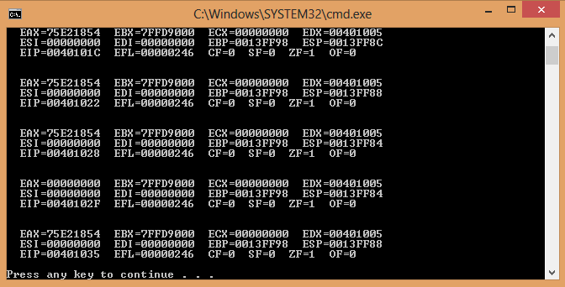

INCLUDE Irvine32.inc;

.data

Msg1 BYTE "Nothing is impossible, I am doing nothing.",0

.code

main PROC

mov edx,OFFSET Msg1

call WriteString

call Crlf

call Crlf

call Crlf

mov ecx,lengthof Msg1

dec ecx ;to remove the null character's length from string length

mov esi,0

Labl1:

movzx eax,Msg1[esi] ; get char by char

push eax ;push on stack

inc esi

loop Labl1

XOR ESI,ESI

mov ecx,lengthof Msg1

dec ecx

Labl2:

pop eax

mov Msg1[esi],al

inc esi

loop Labl2

mov edx,OFFSET Msg1

call WriteString

call Crlf

call Crlf

call Crlf

call Crlf

exit

main ENDP

END main

**Output**

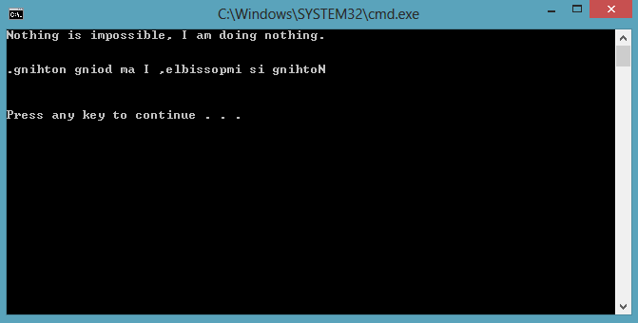

### PUSHFD & POPFD Instruction

**PUSHFD:** pushes 32 – Bit EFL register on the stack.

**POPFD:** pops – 32 Bit EFL register from the stack into EFLAG.

pushfd

popfdf

A sample is given below to show how the contents of flags are saved and restored.

; copy this code into main procedure

mov al,0

pushfd ;save the current flags

call dumpregs

inc al ;change in flag(s)

call DumpRegs

popfd ;it restores the flags as it was before computation

call DumpRegs

### PUSHAD, PUSHA & POPAD, POPA Instruction

**PUSHAD:** pushes all 32 – Bit general purpose registers on the stack in the following order

EAX, ECX, EDX, EBX, ESP, EBP, ESI and EDI

**POPAD:** pops – 32 Bit registers in the reverse order as by PUSHAD

**PUSHA:** pushes all 16 – Bit registers in the order. AX, CX, DX, BX, SP, BP, SI and DI

**POPA:** pops – 16 Bit registers in the reverse order as by PUSHA

PUSHAD ; 32 – Bit Registers

POPAD

PUSHA ; 16 – Bit Registers

POPHA

TITLE Instructions PUSHAD,POPAD

; copy this code into .data section

Msg1 BYTE "for 32 - bit registers",0

; copy this code into main procedure

; 32 - bit registers

mov edx,OFFSET Msg1

call WriteString

call Crlf

XOR EAX,EAX

XOR EBX,EBX

XOR ECX,ECX

XOR EDX,EDX

call DumpRegs

pushad

mov eax,12345678h

mov ebx,5678h

mov ecx,1234h

mov edx,1359h

call DumpRegs

popad

call DumpRegs

TITLE Instructions PUSHA, POPA

; copy this code into .data section as variable declaration section

Msg2 BYTE "for 16 - bit registers",0

; copy this code into main procedure

;16 - bit registers

mov edx,OFFSET Msg2

call WriteString

call Crlf

XOR EAX,EAX

XOR EBX,EBX

XOR ECX,ECX

XOR EDX,EDX

call DumpRegs

pusha

mov ax,1234h

mov bx,5678h

mov cx,1357h

mov dx,2468h

call DumpRegs

popa

call DumpRegs

## Procedures

A Procedure is a named block of statements that ends in a return statement. It is good programming practice to divide your program into procedures. In assembly PROC and ENDP Directives are used for procedures.

Following is an assembly language procedure named sample:

sample PROC

.

.

.

ret

sample ENDP

**Adding 3 Numbers**

INCLUDE Irvine32.inc;

.data

.code

main PROC

mov eax,12d

mov ebx,228d

mov ecx,10d

call sum

call WriteInt

call Crlf

exit

main ENDP

sum proc

add eax,ebx

add eax,ecx

ret

sum endp

END main

**Note**

The CALL instruction calls a procedure

* pushes offset of next instruction on the stack
* copies the address of the called procedure into EIP

The RET instruction returns from a procedure

* pops top of stack into EIP

**What about nested procedure calls?**

### Local and Global Labels

A local label is visible only to statements inside the same procedure. A global label is visible everywhere.

main PROC

jmp L2 ; error

L1:: ; global label

exit

main ENDP

sub2 PROC

L2: ; local label

jmp L1 ; ok

ret

sub2 ENDP

### Passing Parameters to Procedures

An example of summation.

The ArraySum procedure calculates the sum of an array. It makes two references to specific variable names:

ArraySum PROC

mov esi,0 ; array index

mov eax,0 ; set the sum to zero

mov ecx,LENGTHOF myarray ; set number of elements

L1: add eax,**myArray**[esi] ; add each integer to sum

add esi,4 ; point to next integer

loop L1 ; repeat for array size

mov **theSum**,eax ; store the sum

ret

ArraySum ENDP

**Alternatively**

This version of ArraySum returns the sum of any doubleword array whose address is in ESI. The sum is returned in EAX:

ArraySum PROC

; Receives: ESI points to an array of doublewords,

; ECX = number of array elements.

; Returns: EAX = sum

;-----------------------------------------------------

mov eax,0 ; set the sum to zero

L1: add eax,[esi] ; add each integer to sum

add esi,4 ; point to next integer

loop L1 ; repeat for array size

ret

ArraySum ENDP

### USES Operator

INCLUDE Irvine32.inc;

.data

.code

main PROC

call dumpregs

call sample

call dumpregs

exit

main ENDP

sample PROC USES esi ecx

mov esi, 12345678h

mov ecx, 87654321h

call dumpregs

ret

sample ENDP

END main

The code shown in red is automatically generated

sample PROC

push esi

push ecx

.

.

pop ecx

pop esi

ret

sample ENDP